FlyingBuddy2: Brain Controls A Quadrotor for the Handicapped (Ubicomp 2012)

Researchers based at Zhejiang University in China have produced a system for controlling a quad-rotor unmanned aerial vehicle with the mind. Dubbed "Flying Buddy 2", the system uses a standard, commercially-available [Electroencephalogram](https://newatlas.com/the-first-commercially-available-brain-computer-interface/6971/) (EEG) headset, a computer and a Parrot [AR Drone](https://newatlas.com/parrot-ar-drone-release-price/16612/). The computer processes the data received from the EEG and converts it into control commands which are beamed to the drone via a Wi-Fi connection. Judging by the video, the latency of the setup appears to be relatively low.

They Showed that,

In order to control an airborne vehicle with the mind requires that one first learn some commands. For example, in order to make the drone take off or land, the user must think left hard, while rotating can be achieved by thinking left lightly - the drone was also configured to take pictures if the user blinked. This all sounds rather demanding, but like other mind-control systems we've seen such as the [EEG-controlled wheelchair-mounted robotic arm](https://newatlas.com/brain-control-wheelchair-robotic-arm/10954/), mastering the controls no doubt becomes much easier with practice.

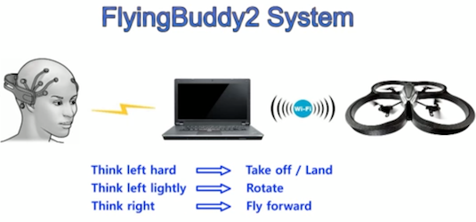

Various demonstrations of the Flying Buddy 2 technology were thought up by the scientists, including a "boxing match" which pitted a mind-controlled drone against one piloted with a typical remote setup. Each controller was tasked with pushing the opposing device out of the allotted area. The mind-controlled drone research is aimed toward enabling the disabled to interact with their environment in new ways, however it does not take too big a stretch to imagine a more mature implementation of the tech being attractive to those in the consumer, transport, industry and defense sectors.